# Demonstrate Validation testing

Code:

**package** TestCases;

**import** org.openqa.selenium.By;

**import** org.openqa.selenium.WebDriver;

**import** org.openqa.selenium.chrome.ChromeDriver;

**public class** Validations_Test {

**public static void** main(String []args)

{

System.*setProperty*("Webdriver.chrome.driver","C:\\STQA\\Drivers\\chrome driver.exe");

WebDriver driver = **new** ChromeDriver(); driver.get(["https://www.google.com/"](http://www.google.com/));

String title =driver.getTitle(); // Check the validation of title System.***out***.println("title is" +title); System.***out***.println(driver.getCurrentUrl()); //Check the validation of

URL

// # Check the validation of the Search box is Visible are not.

**boolean** status =

driver.findElement(By.*xpath*("/html/body/div[1]/div[3]/form/div[1]/div[1]/div[ 1]")).isDisplayed();

**if**(status){

System.***out***.println("Search box is visible");

} **else** {

System.***out***.println("Search box is hidden");

}

}

}

Output:

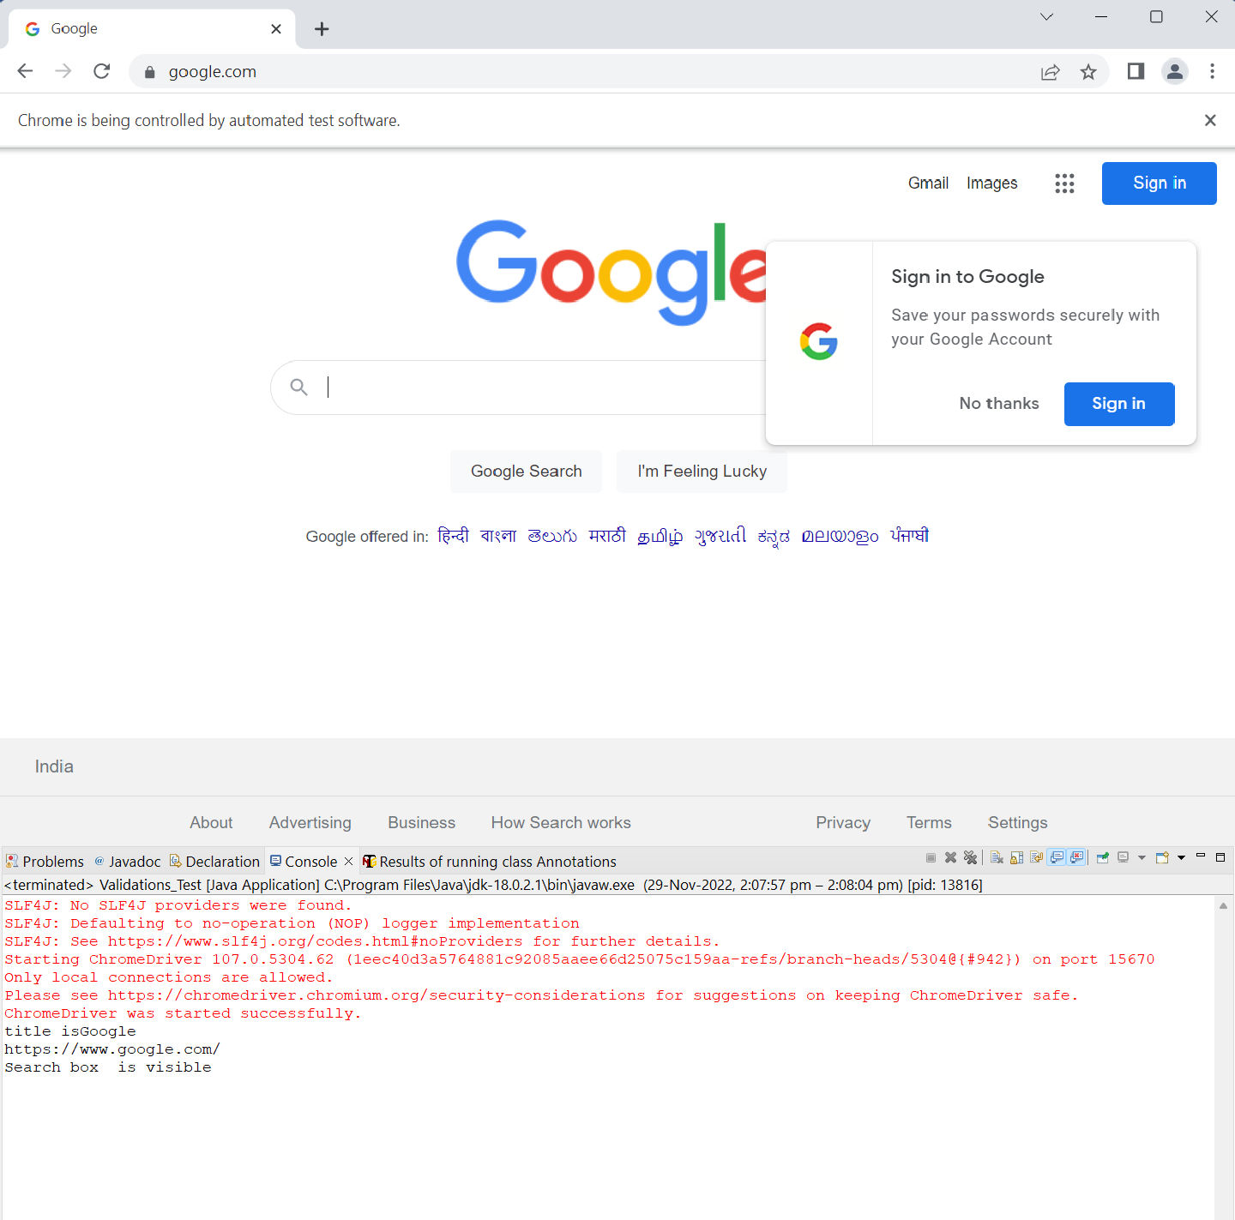

# Perform regression testing

## Retrying failed test cases using listeners in TestNG. Code:

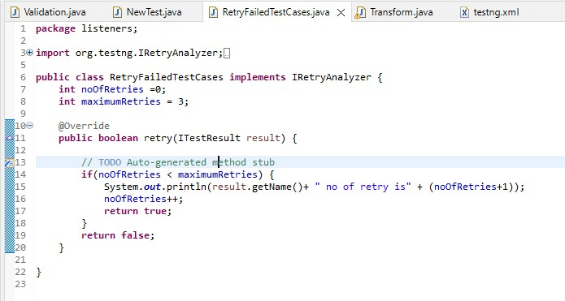

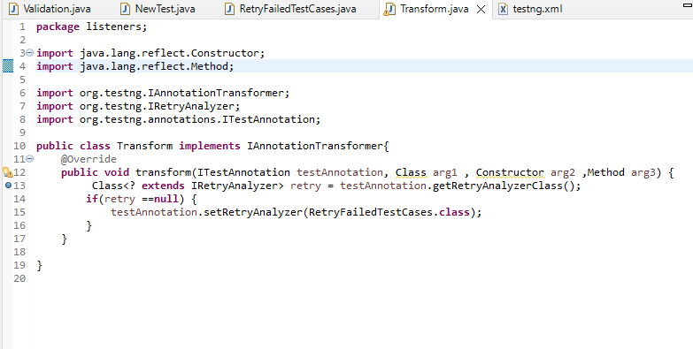

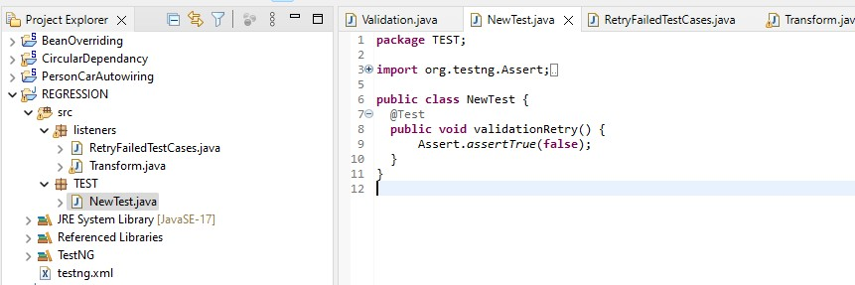

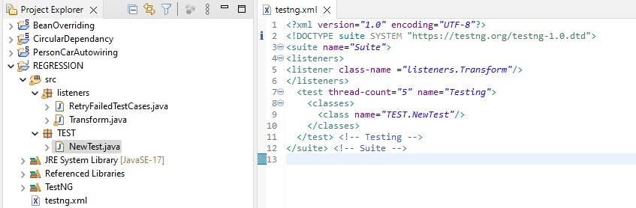

Output:

